Meeting 13th July 2026
Meeting minutes:
- Can unhook from tensioned position on bicep and hook back onto a strap on forearm so the cable isn’t tensioned
- Claw naturally closed so can lift dumbells etc when it’s unhooked
- Can have different widths of the claw, e.g. make it the thickness of a thumb, perhaps hook through a small circle like a mug handle?
- Varun mocked up on blender 2- and 3-segment claw of different/same lengths

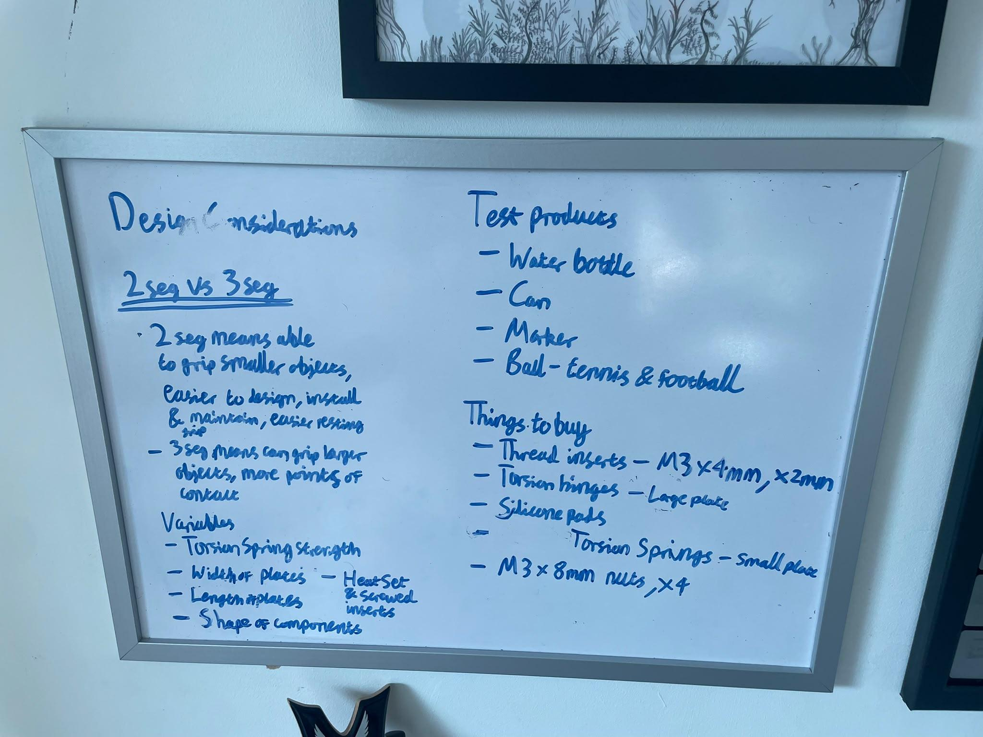
- Foam liner or silicon for inside of plates
- Silicon tip on claws for higher friction if gripping a straw/pen/small diameter object
- Could still do right hand, but with ability to write (e.g. notch in prosthetic finger to hold pencil)

